**Observation of a single file**

Data file Name : N_IBI_BM_b_10_5_hrv_e.txt

Size of data : 306 X 1

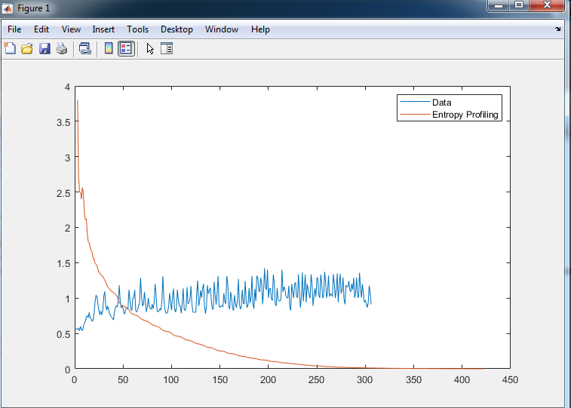

Sampling Profiling size : 418

Mean of sampling Profiling : Inf (considering all sample profiling)

Mean of sample Profiling : 0.3337 (only considering sample profiling with real value)

Note:- the first reading is Inf

Note:- some files have first two value Inf. Eg, In ECG_BC_c_25_8_hrv.txt first two reading is Inf.

**Results from 15 RR files attached with this email.**

0.1560 0.3630 3.0910 0 0.5474 2.0000

0.0792 0.2450 3.7612 0 0.5066 1.0000

0.0415 0.1340 2.3888 0 0.3498 0

0.0892 0.2362 3.1355 0 0.4977 0

0.0939 0.1709 2.2156 0 0.3251 2.0000

0.1048 0.2317 2.2083 0 0.3911 2.0000

0.0961 0.1997 2.6548 0 0.3898 2.0000

0.0985 0.3424 2.5903 0 0.5513 0

0.0543 0.1733 2.5649 0 0.3758 0

0.0287 0.1065 1.6761 0 0.2770 0

0.0384 0.1257 2.3795 0 0.3545 0

0.0811 0.2266 3.8067 0 0.5726 0

0.0921 0.2223 2.6391 0 0.4185 1.0000

0.0294 0.1203 2.5649 0 0.3144 0

0.1499 0.3337 3.8067 0 0.5294 2.0000Col1: sample entropy from datashare

Col2: mean(sample entropies profile)

Col2: max of sample entropies profile

Col3: min of sample entropies profile

Col4: std of sample entropies profile

Col5: number of Inf in entropies profile

Parameters used:

In Datashare sample Entropy:

m-> embedding dimension ->2

r -> 2*std(data)

Parameter used in the algorithm

m->embedding Dimension -> 2

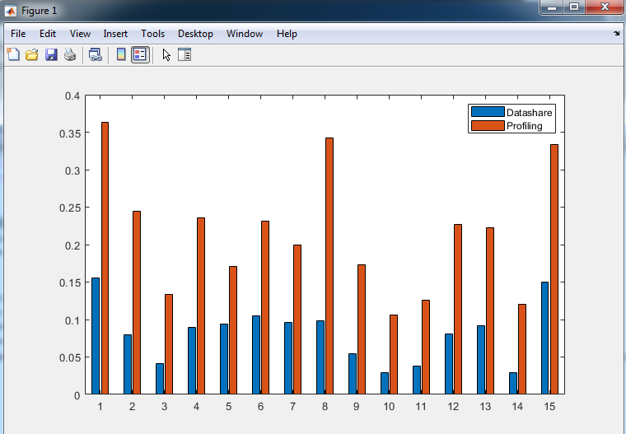

Bar diagram of the sample entropies from data share and mean of the sample profiling.

**Questions:**

1. **Do we need to remove all Inf from the entropy profiling ??**
2. **To get the sample entropy from the entropy profiling do we get the mean of the sample entropy ??**